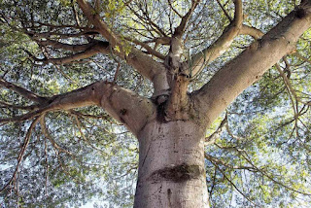

Trees hold our precious earth together to prevent floods. They give us fire for wood and building shelters. Some give us fruits and food from their leaves. They work ceaselessly to convert all of the carbon we mindlessly dump into the atmosphere only to give us oxygen to live. Although it is commonly known that the leaves, fruit, root and bark of many trees have medicinal properties, their mystical properties are less known. I believe the medicinal and mystical trees are more conscious than most human beings on this planet at this time.
There was a Mayan yogi who always sat in meditation under the ceiba tree. Yogis in India meditate under the neem tree. Also, the Buddha attained nirvana under the Bodhi tree.
The Tree Tantra
One takes the tree as a symbol for meditation while at the same time taking actual shelter under the tree and participating with its shield of electromagnetic energy while meditating. According to Mayan mystics “nothing evil can happen while under the ceiba.” The upward force growing out of the earth helps awaken the kundalini while the downward force of converting air into mass and developing deep roots into the earth helps bring the kundalini back down. Mind must fly upward toward the spirit but also must return to the earth, at least for as long as one is on this earth. Just like the Indian Yogis, this mayan yogi said that a yogi completes his spiritual practice by bringing the kundalini back down, from the crown and back down into the spiritual heart. This gives a base for the mind mid-way along the spinal column. One can be joyfully engaged in existence here and remain in a subtle state of being while at the same time keep oneself grounded and in the body. Like the great ceiba tree, one extends high into the heavens while also rooting oneself deep into the earth. Unchecked kundalini force will eventually liberate you but it can kill your body if not careful. One gets attached to spiritual bliss and experiences but must know how to balance them out. It is better to save that intensity for when it is really time to leave all work and thereby the physical body, and never before then. Like the Upanishad says, “Desire to live 100 years while working in joyful, infinite unity.”
Subscribe to my mailing list by sending an email to enckwilliam@protonmail.com

